**Git Commands**

* Some Linux command used in it git for directory manipulation
  + **pwm:** present working directory; shows in which directory we are in.
  + **ls:** list the content of the directory we are in.
  + **cd:** change the directory
  + **touch <file name>:** to create a file
* **git status:** shows the status of the directory we are in.
* **git add - - a:** to add files in the staging area.
* **git commit -m “message”:** commit the file to git.
* **Rm -rf .git:** to remove the directory from git.
* **git clone url name**( if want to change name)**:** clones a remote git repository
* **Q :** by clicking Q we can exit from different options

**Git File status**

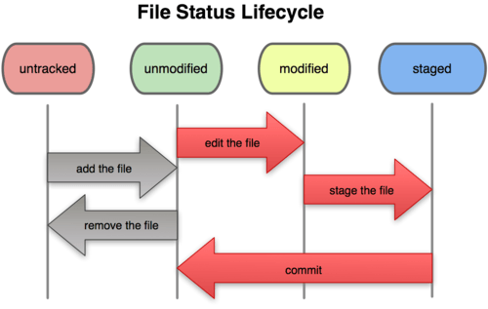

**File status life cycle:** When we track the untracked files first time instead of saying that they are in staged we say they got unmodified (just for the first time), after that whenever we modify these files they will become modified, after which whenever we track these file again they will go to staged and then when we commit the files they will become unmodified again.

* When we modify a file which is still in the staging area (the area in which ready to commit files are placed.) then it will be present in both staging area and modified area, but in staged the version of file is before it get modified which is ready to get commit and in modified area new modified file is present.

When we commit the file, the file in staging will get committed not the modified one and we will still have the both version of the file (that’s why staging area is used to avoid these kind of situations).

But if we add the modified file in staging area it will replace the already existing in staging area it will become the only version of file present.